**CIS 424 Quality Assurance - Evaluation Procedures for Project Issues**

1. A QA evaluator will evaluate his/her assigned area with test cases and sample data.
2. For each discovered issue, the QA evaluator will submit and maintain an issue on GitHub.
   1. The title needs to contain the tested form and a brief description of the issue.



* 1. The body needs to have the following :

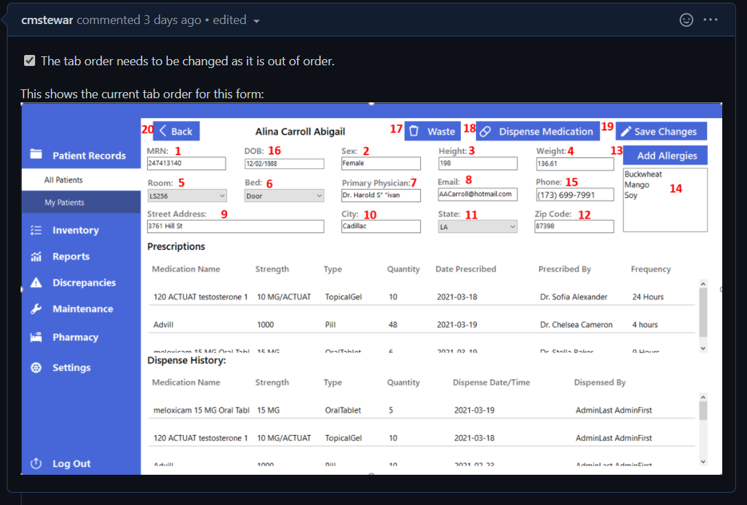

* + 1. Data used (specific) that caused the error.
    2. Error in VS related to the bug (if applicable)
    3. Screenshots of the error/data and problems
    4. Description of the problem
    5. List ( - [ ] ) of items to be fixed
  1. The issue is to be assigned to Eric Lavoie to distribute it to the person handling that area.
  2. The appropriate labels need to be attached to help describe the issue and make it sortable for reporting



* 1. The issue needs to be attached to the Project Three Team Board and assigned to the appropriate milestone for tracking and reporting





1. All issues need to be added to the author's Task Sheet as this is the only snapshot Dr. James has to see what each team member is working on.

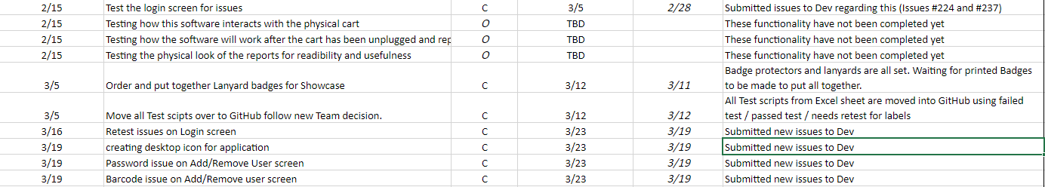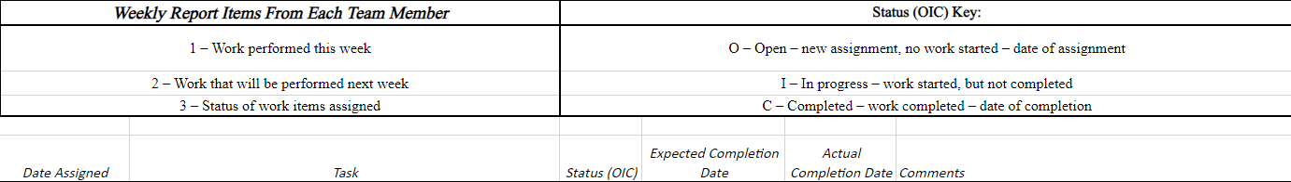

1. As an issue is closed by the Development team, we need to retest our original findings making sure it has been resolved, and there are no new issues caused in the process.

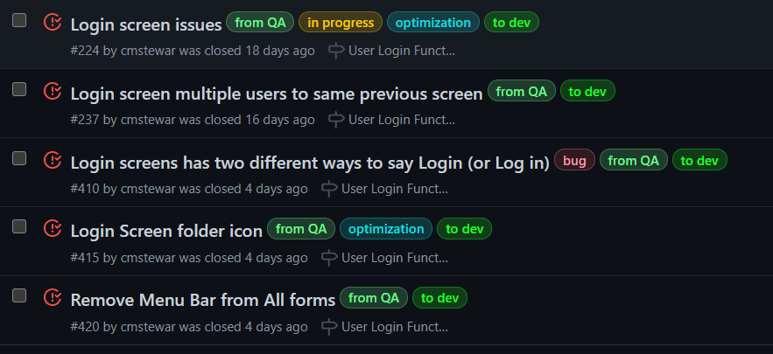



1. To log a test and its findings, we will create an issue in GitHub.
   1. The title will contain a brief description of the test performed



* 1. The body will have a complete description of the test and any sample data used. It will also include the Expected and Actual results of the test.

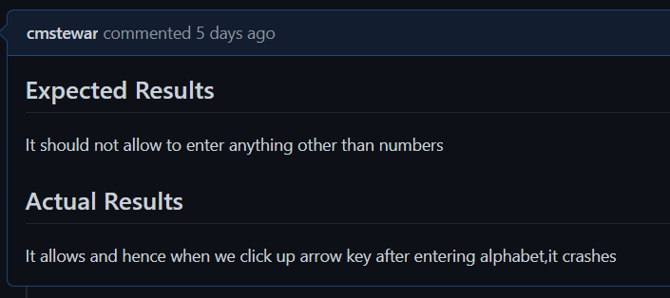

* 1. The appropriate labels will be attached to help describe whether it was a Passed Test, Failed Test, and needs Retesting. These will help us down the road as we need to track tests moving forward.



* 1. The test needs to be attached to the Project Three Team Board and assigned to the appropriate milestone for tracking and reporting



* 1. The test then needs to be Closed to remove it from the Development column and place it in the Quality Assurance column to keep track of it.

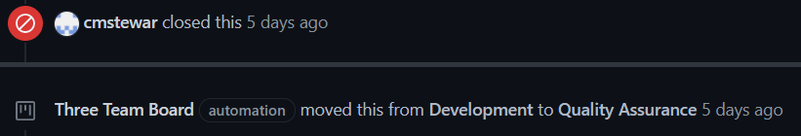

1. The group leader will keep the group aware of new areas for testing and assign them as they see fit.

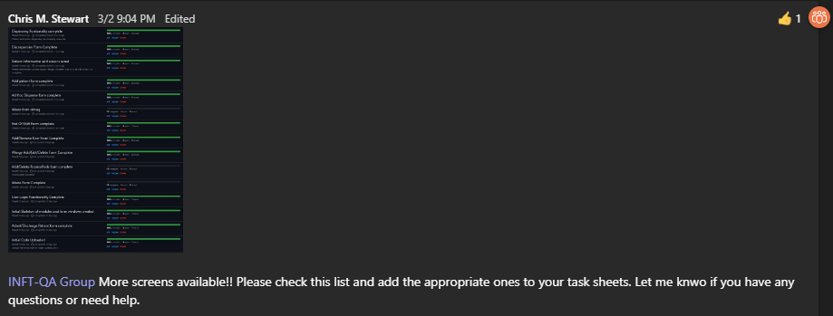



1. On Fridays, the group leader will go over the group members' task sheets, making sure they are accurate. They will combine them on the leader's sheet and send them to Dr. James to keep him updated on our progress.

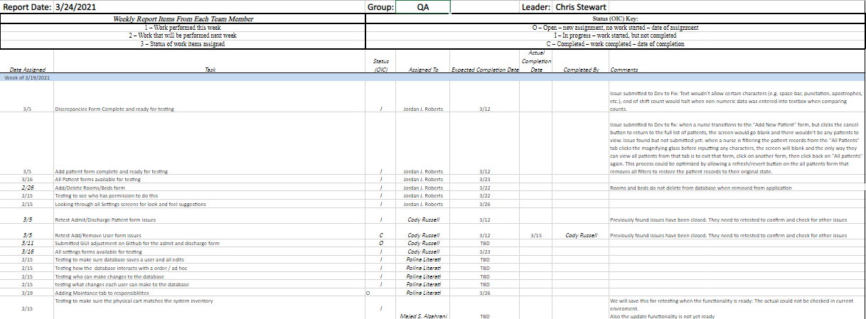

1. We will have a mandatory meeting every Monday at 8 pm in Teams to discuss any new information and discuss any questions/issues.



1. We will also have periodic meetings for testing through Teams. These will not be mandatory but will allow us to collaborate while testing to ensure we are seeing the same thing and submitting issues effectively.

